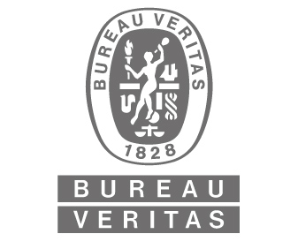

BUREAU VERITAS ( KOREA )

Request for Recruitment

Position Justification
Division | Marine & Offshore
Department | MMS
Open Position | 1
Job Title | (English) Inside Marketing & Sales Administrator
 | (Korean) 마케팅 & 영업 관리자
Job Location | Seoul, Korea
Job Family
N+1 Manager | Shipowners Marketing & Sales Manager
Contract Condition
If “Contracted” or “Subcontracted”, contract duration : ____1__ years
*Potential for Permanent Position Review after 1 year
Gender | Male or Female
Age bracket
Banding |  | Level
Annual salary package or Service Fees

Reason for Recruiting
New Position
Replacement
In Budget

Qualification
Educational Back ground | Essential  - Bachelor’s degree in Business Administration, Marketing, or a related field.  Desirable  - Background in maritime or engineering is a plus
Work experience required (fields, number of years….) | Essential  - 1+ years of experience in administration, sales support, or marketing coordination.  Desirable  - Experience in a B2B environment, classification society, or maritime industry.

Required Language (Level) | Essential  - Proficient in English (written)  Desirable  - Proficient in English (spoken) is a plus.
Required Skill or  Job related skills | (Tech, IT knowledge, others.,…)  Technical & IT Knowledge:  • Proficiency in Microsoft Office (Excel, PowerPoint, Word).  • Experience with CRM tools (Salesforce preferred).  Other Skills:  • Strong organizational and administrative abilities.  • Effective communication and coordination skills.  • Ability to manage multiple tasks and deadlines efficiently.

Job Description
1. Administrative Support for Marketing & Sales
• Prepare reports, sales data, and marketing materials to support the Shipowners Marketing & Sales team.
• Handle expense management and other administrative coordination.
• Maintain and update client databases, internal records, and CRM tools (e.g., Salesforce).

2. Customer & Sales Support (Internal Focus)
• Support communication with shipowners and industry stakeholders by handling inquiries and document requests.
• Assist in preparing quotations, contracts, and agreements under the guidance of the Marketing & Sales Manager.
• Coordinate meeting schedules, follow-up emails, and internal communication to ensure smooth operations.

3. Market & Competitor Research
• Gather and organize market intelligence and competitor analysis data to assist strategic planning.
• Monitor industry trends and support in creating internal reports and presentations.

4. Coordination & Documentation
• Assist in organizing internal and external events, webinars, and training sessions.
• Prepare and maintain standardized templates for reports, proposals, and presentations.

Recruitment Process
Sourcing  (please check) | Internal mobility
Sourcing  (please check) | External sourcing | Advertisement
Sourcing  (please check) | External sourcing | Head Hunting
Sourcing  (please check) | External sourcing | Internet Sites
Sourcing  (please check) | External sourcing | Recommendation by internal staff
Sourcing  (please check) | External sourcing | Sub-Contract Company
Expected starting date
Interview Schedule | 1st : |  | Interviewer :
Interview Schedule | 2nd : |  | Interviewer :

Requested by Approved by
Name : Sang-Jin Han Name :
Date : March 7, 2025 Date :
Signature : Signature :


